How to remove first 3 characters from a string in Excel

In some cases, dates may be stored in a string format that includes unnecessary characters at the beginning. Removing the first three characters can help convert the string into a recognizable date format that Excel can interpret correctly.

The following dataset contains valuable information about the employees in the company, including their names, job departments, genders, dates of joining, and office locations in different regions. The names in the dataset follow a format where the first and middle names are abbreviated and separated by a dot (.) and we need to exclude these first three characters from the name string.

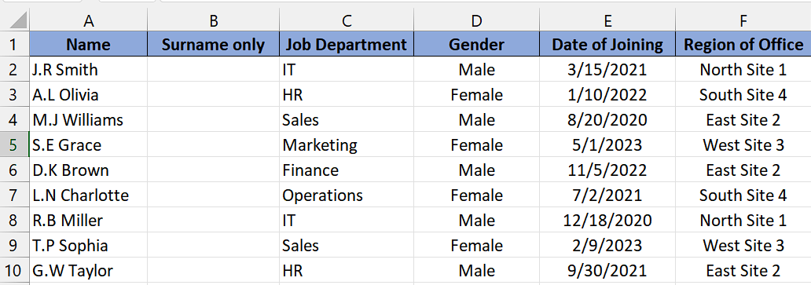

Following are 4 suitable ways to do it:

## Method 1 – By using REPLACE Function

## Understanding the Functions and their Syntax

* **REPLACE Function:**
* **The REPLACE function** is a commonly used function in many programming languages and spreadsheet applications, including Microsoft Excel. It is used to replace a specific portion of text within a given string with new text.
* The syntax for the REPLACE function is typically as follows:

**=REPLACE(old_text, start_num, num_chars, new_text)**

* **"old_text"** is the **original text** string or cell reference in which the replacement will occur.
* **"start_num" is the starting position** within the original text where the replacement will begin.
* **"num_chars" is the number of characters** to be replaced, starting from the specified starting position.
* **"new_text" is the new text** that will replace the specified portion of the original text.

## Step 1 – Selecting the cell

* **Select an empty cell** in which you want the text with excluded characters.
* In this cell, we will apply the **REPLACE Function.**



## Step 2 – Writing and implementing the formula

* After following the above step, **press = button** on your keyboard and write **REPLACE** and select the **REPLACE Function** by utilizing **tab button.**
* After that **select** or **write the name** of **cell** of which you want to **remove characters.** For instance, we have selected the **cell A2.**
* Then, **write “1” (without quotes)** in parameter **start_num.** Here, 1 represents the **starting position** within the text **where the replacement will occur.** In this case, it is the first character of the text.
* Now, **type “3” (without quotes)** in the next parameter **num_chars** which indicates the number of characters to be replaced, starting from the specified starting position. Here, it **replaces** the **first three characters of the text.**
* In the fourth parameter **new_text**, just enter two quotes without any space just like this **("") without parenthesis** which means it is an **empty string.** Since an empty string is provided, the **replaced characters are effectively removed.**
* Then add a **closing parenthesis** and your formula would look like this,

=REPLACE(A2,1,3,"")

* After that, **press Enter** and the **result would appear** in the selected cell.



## Step 3 – Implementing formula to the whole range

* To apply the formula to a range of cells, **select the cell where the result has appeared,** such as **cell B2** in this case.
* Next, **hover** your cursor over the **bottom right corner of the cell** until it **transforms into a "+" shape**, known as the **fill handle.**
* **Double-click on the fill handle** to automatically apply the **formula** to the **entire range** **of cells.**



## Method 2 – By using RIGHT and LEN functions

## Understanding the Functions and their Syntax

* **RIGHT Function:**

## In Excel, **the RIGHT function** enables you to extract a designated number of characters from the right side of a text string.

## The syntax for the RIGHT function is as follows:

## **=RIGHT(text, num_chars)**

## **The "text" parameter** represents the **text string** you wish **to extract characters from.**

## **The "num_chars" parameter** indicates the **number of characters** you want to retrieve **from the right side** of the text.

* **LEN Function:**

## **The LEN function** is a commonly used function in many programming languages and spreadsheet applications, including **Microsoft Excel.** When the LEN function is applied to a text string, **it returns the count of characters in that string**, including letters, numbers, spaces, punctuation marks, and any other special characters.

## The **syntax** for the LEN function is typically as follows:

## **=LEN(text)**

## **"text"** is the **input string or cell reference** containing the **text whose length** needs **to be calculated.**

## Step 1 – Selecting the cell

* **Select the cell** in which you want the text with excluded characters.
* In this cell, we will apply the **RIGHT and LEN Function.**



## Step 2 – Writing and implementing the formula

* Once you’ve selected the cell, **press = (equal sign) button** on your keyboard.
* Then, **type RIGHT** and select the **RIGHT Function** byusing the **tab button** on your keyboard.
* After that **select** or **write the name** of **cell** of which you want to **remove characters.** For instance, we have selected the **cell A2.**
* Now, type **comma (,)** and then write **LEN** and select the **LEN Function** by using **tab button** on your keyboard.
* **Again, choose or enter the cell** name from which you **wish to eliminate characters.** For example, let's consider we have **selected cell A2.**
* Then, **write -3** as we want to **exclude three characters.**
* The utilization of the **LEN function with -3 in num_chars parameter ensures** the **exclusion** of the **initial three characters** from the cell.
* Then add a **closing parenthesis** and your formula would look like this,

=RIGHT(A2,LEN(A2)-3)

* After that, **press Enter** and the **result would appear** in the cell.



## Step 3 – Implementing formula to the whole range

* To apply the formula to a range of cells, **select the cell where the result has appeared,** such as **cell B2** in this case.
* Next, **hover** your cursor over the **bottom right corner of the cell** until it **transforms into a "+" shape**, known as the **fill handle.**
* **Double-click on the fill handle** to automatically apply the **formula** to the **entire range** **of cells.**



## Method 3 – By using VBA code

## Step 1 – Adding a module

* For adding a module, navigate to **Developer tab.**
* After that, click on the **first option** named as **Visual basic.**
* You’ll see a **new window on your screen** and you can **also** **open this window** by using **shortcut key** (**Alt+F11**) as well.
* Then, click on the **Insert tab** in this window and click on the **Module option.**
* Now, a **new module would open.**



## Step 2 – Writing the code

* After you’ve opened the module, copy and paste the following code:

Public Function Rmv_3_ltr(rng As String, cnt As Long)

' This function removes a specified number of characters from the right side of a text string.

' Calculate the length of the original text string.

' Subtract the specified count from the length to determine the number of characters to keep.

Rmv_3_ltr = Right(rng, Len(rng) - cnt)

' Return the modified text string.

End Function

* Now, press **Ctrl+S** to save it. After that close the window.



## Step 3 – Selecting the cell for using created Function

* **Select the cell** in which you want the text with excluded characters.
* In this cell, we will **apply the function** that is created by us.



## Step 4 – Using the created function

* In the selected cell, type **“Rmv_3_ltr”** (without quotes) or the **name** that you have **given to the function.**
* **enter the cell** name from which you **wish to eliminate characters.** For example, let's consider we have **selected cell A2.**
* Then, **type 3** and **close the parenthesis.**
* Now, **press Enter** and **result would appear** in the cell.



## Step 5 – Implementing formula to the whole range

* To apply the formula to a range of cells, **select the cell where the result has appeared,** such as **cell B2** in this case.
* Next, **hover** your cursor over the **bottom right corner of the cell** until it **transforms into a "+" shape**, known as the **fill handle.**
* **Double-click on the fill handle** to automatically apply the **formula** to the **entire range** **of cells.**

